PD900-I Colorful LCD Display

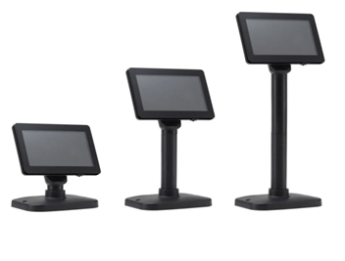

|  |  |
| --- | --- |
| DISPLAY SIZE | 9.7 Inch wide |
| Technical Solution | DISPLAYLINK |
| Interface | USB2.0 |
| Resolution | 800x600 / 1024x768 |
| Power Supply | ONLY USB 5V |
| Display Area | 162(H)X121(V)mm(4:3) |
| Display Type | High Brightness TFT-LCD(Digital-Panel) |
| Back Light | LED |
| White Luminance | 450Nite |
| Response Time | 25ms |
| Viewing Angle | 350°(Horizontal),60°(Vertical) |
| Temperature | Operating:-20℃ -45℃ |